**LAB#7**

**Task 4** - Develop a program to perform two simple transactions in a bank as long as user enters y/Y. to continue

Source code

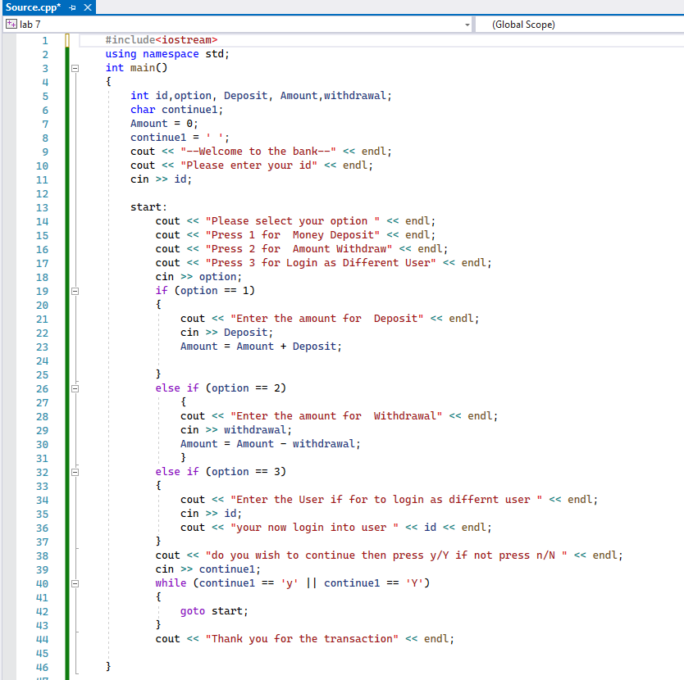

Output

